**Lab 20: Android Shared Preferences**

# **Introduction**

# Key-value pairs of basic data are stored and retrieved using the Android SharedPreference class. String, integer, long, and number are regarded as primitive data types in Android. We can access the values based on their keys thanks to the key-value pair. It is frequently employed to gather data from users, such as that related to application or device settings.

**Let’s get Started:**

In this Exercise we will develop an Android App to demonstrate the use of Android Shared Preferences.

**Step 1: Create a New Project in Android Studio as shown below**

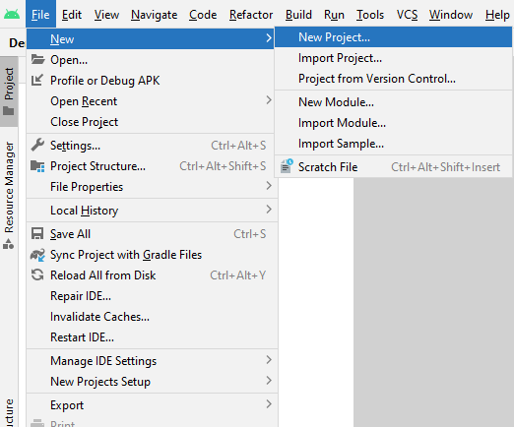

**Step 2: Select Empty Activity as shown below**

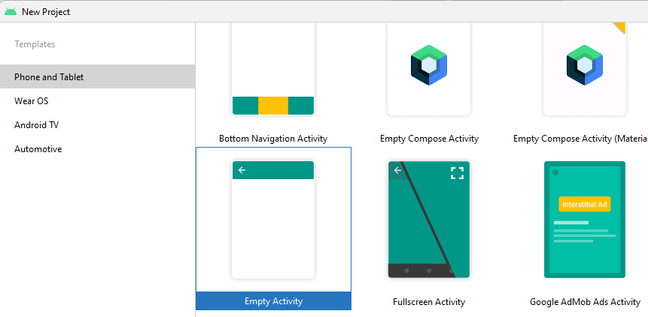

**Step 3: Provide a Project Name as shown below**

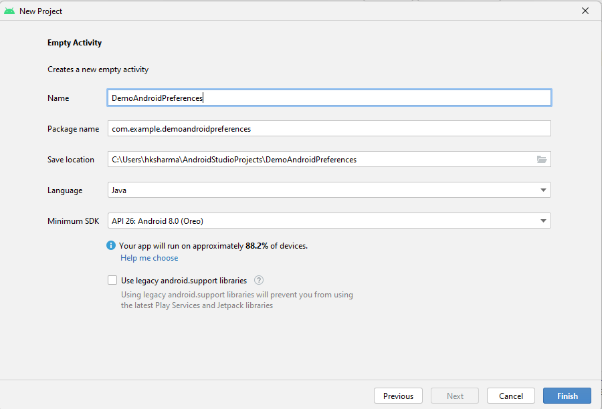

**Step 4: Update MainActivity.kt as per the code given below**

**package** com.example.demosharedprefkotlin  
**import** android.content.Context  
**import** android.content.SharedPreferences  
*//import android.support.v7.app.AppCompatActivity***import** android.os.Bundle  
**import** android.view.View  
**import** android.widget.Button  
**import** android.widget.EditText  
**import** android.widget.TextView  
**import** androidx.appcompat.app.AppCompatActivity  
  
  
**class** MainActivity : AppCompatActivity() {  
  
 **private val** sharedPrefFile = **"kotlinsharedpreference"  
  
 override fun** onCreate(savedInstanceState: Bundle?) {  
 **super**.onCreate(savedInstanceState)  
 setContentView(R.layout.activity_main)  
  
 **val** inputId = findViewById<EditText>(R.id.editId)  
 **val** inputName = findViewById<EditText>(R.id.editName)  
 **val** outputId = findViewById<TextView>(R.id.textViewShowId)  
 **val** outputName = findViewById<TextView>(R.id.textViewShowName)  
  
 **val** btnSave = findViewById<Button>(R.id.save)  
 **val** btnView = findViewById<Button>(R.id.view)  
 **val** btnClear = findViewById<Button>(R.id.clear)  
 **val** sharedPreferences: SharedPreferences = **this**.getSharedPreferences(sharedPrefFile,Context.MODE_PRIVATE)  
 btnSave.setOnClickListener(View.OnClickListener **{  
 val** id:Int = Integer.parseInt(inputId.text.toString())  
 **val** name:String = inputName.text.toString()  
 **val** editor:SharedPreferences.Editor = sharedPreferences.edit()  
 editor.putInt(**"id_key"**,id)  
 editor.putString(**"name_key"**,name)  
 editor.apply()  
 editor.commit()  
 **}**)  
 btnView.setOnClickListener **{  
 val** sharedIdValue = sharedPreferences.getInt(**"id_key"**,0)  
 **val** sharedNameValue = sharedPreferences.getString(**"name_key"**,**"defaultname"**)  
 **if**(sharedIdValue.equals(0) && sharedNameValue.equals(**"defaultname"**)){  
 outputName.setText(**"default name: ${**sharedNameValue**}"**).toString()  
 outputId.setText(**"default id: ${**sharedIdValue.toString()**}"**)  
 }**else**{  
 outputName.setText(sharedNameValue).toString()  
 outputId.setText(sharedIdValue.toString())  
 }  
  
 **}** btnClear.setOnClickListener(View.OnClickListener **{  
 val** editor = sharedPreferences.edit()  
 editor.clear()  
 editor.apply()  
 outputName.setText(**""**).toString()  
 outputId.setText(**""**.toString())  
 **}**)  
 }  
}

**Step 5: Update activity_main.xml for Vertical Orientation as per the code given below**

*<?***xml version="1.0" encoding="utf-8"***?>*<**LinearLayout xmlns:android="http://schemas.android.com/apk/res/android"  
 xmlns:app="http://schemas.android.com/apk/res-auto"  
 xmlns:tools="http://schemas.android.com/tools"  
 android:layout_width="match_parent"  
 android:layout_height="match_parent"** >  
 <**TableLayout  
 android:layout_width="281dp"  
 android:layout_height="253dp"  
 android:layout_marginStart="8dp"  
 android:layout_marginTop="8dp"  
 android:layout_marginEnd="8dp"  
 android:layout_marginBottom="8dp"  
 app:layout_constraintBottom_toBottomOf="parent"  
 app:layout_constraintEnd_toEndOf="parent"  
 app:layout_constraintStart_toStartOf="parent"  
 app:layout_constraintTop_toTopOf="parent"**>  
  
 <**TableRow**>  
  
 <**TextView  
 android:layout_width="wrap_content"  
 android:layout_height="wrap_content"  
 android:layout_column="0"  
 android:layout_marginStart="10sp"  
 android:layout_marginLeft="10sp"  
 android:text="Enter Id"  
 android:textAppearance="@style/Base.TextAppearance.AppCompat.Medium"** />  
  
 <**EditText  
 android:id="@+id/editId"  
 android:layout_width="201dp"  
 android:layout_height="wrap_content"  
 android:layout_column="1"  
 android:layout_marginStart="50sp"  
 android:layout_marginLeft="50sp"  
 android:hint="id"  
 android:textAppearance="@style/Base.TextAppearance.AppCompat.Medium"** />  
 </**TableRow**>  
  
  
 <**TableRow**>  
  
 <**TextView  
 android:layout_width="wrap_content"  
 android:layout_height="wrap_content"  
 android:layout_column="0"  
 android:layout_marginStart="10sp"  
 android:layout_marginLeft="10sp"  
 android:text="Enter Name"  
 android:textAppearance="@style/Base.TextAppearance.AppCompat.Medium"** />  
  
 <**EditText  
 android:id="@+id/editName"  
 android:layout_width="wrap_content"  
 android:layout_height="wrap_content"  
 android:layout_column="1"  
 android:layout_marginStart="50sp"  
 android:layout_marginLeft="50sp"  
 android:hint="name"  
 android:textAppearance="@style/Base.TextAppearance.AppCompat.Medium"** />  
 </**TableRow**>  
  
 <**TableRow android:layout_marginTop="60dp"**>  
  
 <**TextView  
 android:layout_width="wrap_content"  
 android:layout_height="wrap_content"  
 android:layout_column="0"  
 android:layout_marginStart="10sp"  
 android:layout_marginLeft="10sp"  
 android:text="Your Id"  
 android:textAppearance="@style/Base.TextAppearance.AppCompat.Medium"** />  
  
 <**TextView  
 android:id="@+id/textViewShowId"  
 android:layout_width="wrap_content"  
 android:layout_height="wrap_content"  
 android:layout_column="1"  
 android:layout_marginStart="50sp"  
 android:layout_marginLeft="50sp"  
 android:textAppearance="@style/Base.TextAppearance.AppCompat.Medium"** />  
 </**TableRow**>  
  
 <**TableRow android:layout_marginTop="20dp"**>  
  
 <**TextView  
 android:layout_width="wrap_content"  
 android:layout_height="wrap_content"  
 android:layout_column="0"  
 android:layout_marginStart="10sp"  
 android:layout_marginLeft="10sp"  
 android:text="Your Name"  
 android:textAppearance="@style/Base.TextAppearance.AppCompat.Medium"** />  
  
 <**TextView  
 android:id="@+id/textViewShowName"  
 android:layout_width="wrap_content"  
 android:layout_height="wrap_content"  
 android:layout_column="1"  
 android:layout_marginStart="50sp"  
 android:layout_marginLeft="50sp"  
 android:textAppearance="@style/Base.TextAppearance.AppCompat.Medium"** />  
 </**TableRow**>  
 </**TableLayout**>  
  
 <**LinearLayout  
 android:layout_width="fill_parent"  
 android:layout_height="wrap_content"  
 android:layout_marginBottom="16dp"  
 android:layout_marginEnd="8dp"  
 android:layout_marginStart="8dp"  
 android:orientation="vertical"  
 android:gravity="center"  
 app:layout_constraintBottom_toBottomOf="parent"  
 app:layout_constraintEnd_toEndOf="parent"  
 app:layout_constraintHorizontal_bias="0.0"  
 app:layout_constraintStart_toStartOf="parent"**>  
  
 <**Button  
 android:id="@+id/save"  
 android:layout_width="wrap_content"  
 android:layout_height="wrap_content"  
 android:text="Save"** />  
  
 <**Button  
 android:id="@+id/view"  
 android:layout_width="wrap_content"  
 android:layout_height="wrap_content"  
 android:text="View"** />  
  
 <**Button  
 android:id="@+id/clear"  
 android:layout_width="wrap_content"  
 android:layout_height="wrap_content"  
 android:text="Clear"** />  
 </**LinearLayout**>  
</**LinearLayout**>

**Step 6: Check Output on Android Emulator and it should look like as given below**

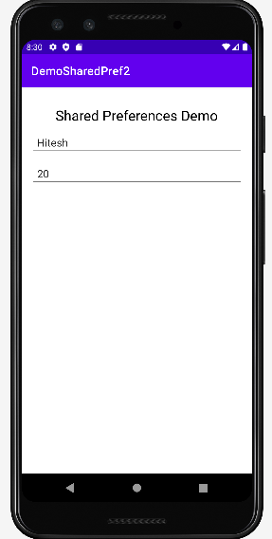

**Voila!!** We have successfully completed this lab.